**Submit the Data from PowerApps controls to SharePoint using Microsoft Flow**

Step 1: Create Flow from Power Apps

* Login <https://powerapps.microsoft.com>
* Click Flows menu in Left Hand Navigation

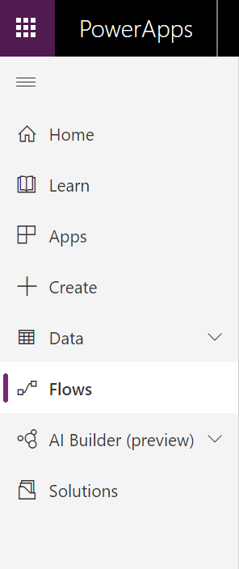

* Create a new flow : New 🡪 Instant – from blank

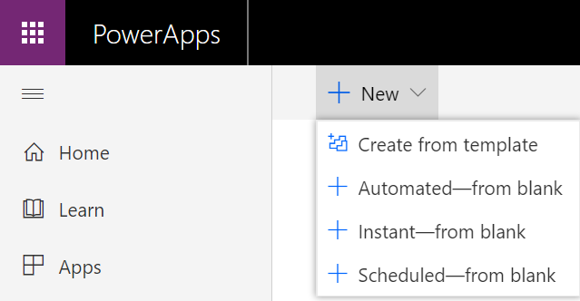

* Select triggers Power Apps

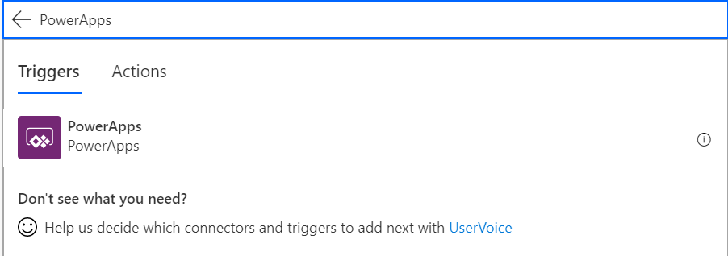

* It will display below screen

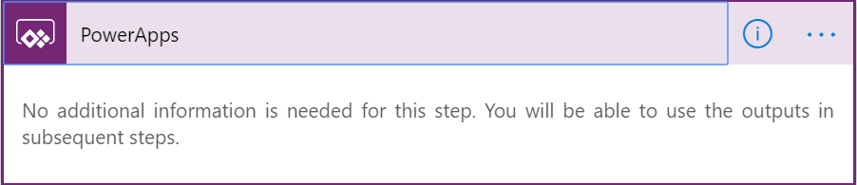

* Click Next Step to add Create Item action to save the data to SharePoint
* Enter Site Address
* Select List Name
  + **Create list named countries with four columns if list not available (Country, State, DOJ, City)**
* Click ‘Ask in PowerApps’ link to add the columns
* Below I have added two columns (Country, State, DOJ, City)

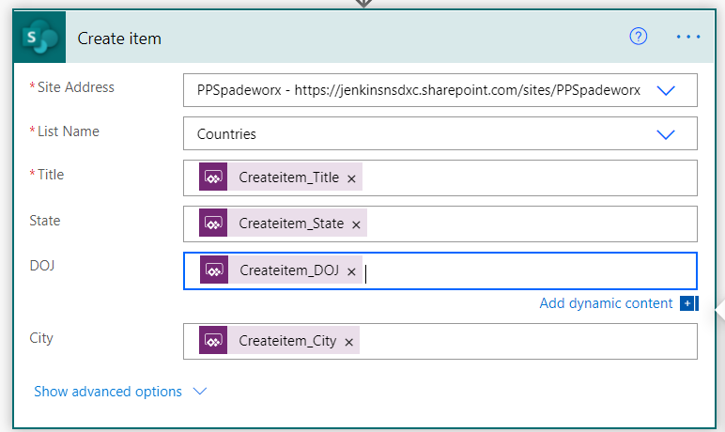

* Click Save link to Save the Flow
* Then you can able to see the flow like below

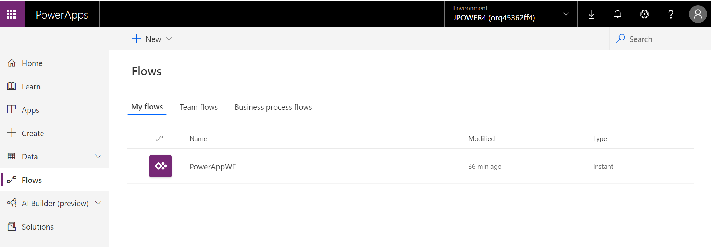

Step 2: Create a Canvas App from blank

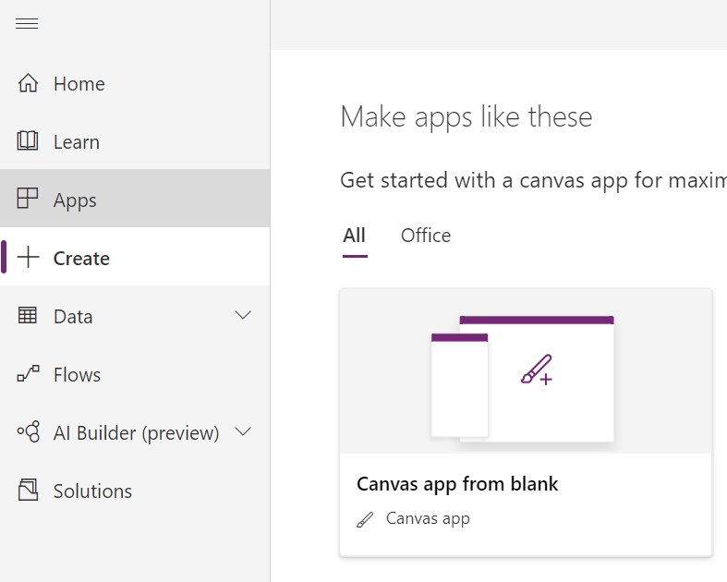

* Add your input controls and Submit button
* Example

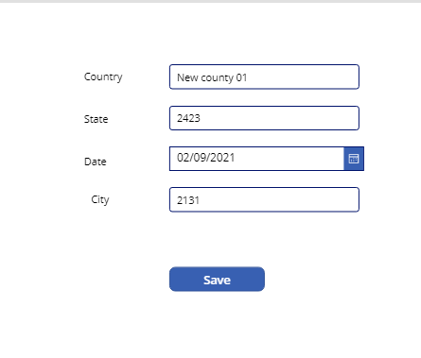

* Select Button – Go to Action Menu – Click PowerAutomate and Add the above created flow

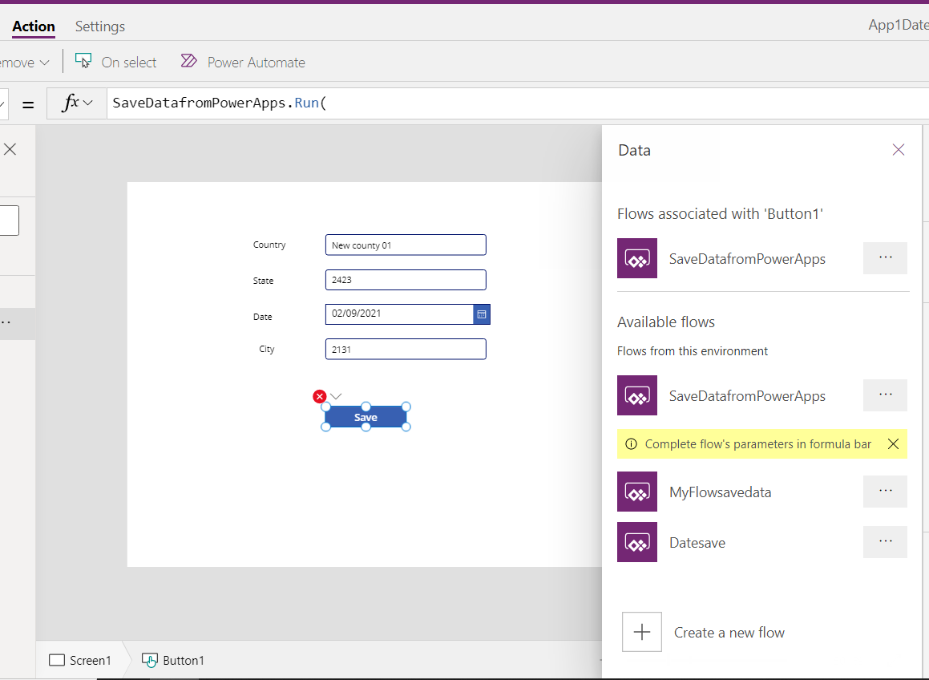

* Then Select Button and add OnSelect Event
  + Add the formula <FlowName>.Run(column1,column2,…)
  + Ex: **SaveDatafromPowerApps.Run(txt_country.Text,txt_state.Text,Text(DatePicker1.SelectedDate, "yyyy-mm-dd"),txt_city.Text)**
* Then Execute the app and test the App and flow.

Then get the status add another action Power apps 🡪 Respond to a Power App or flow

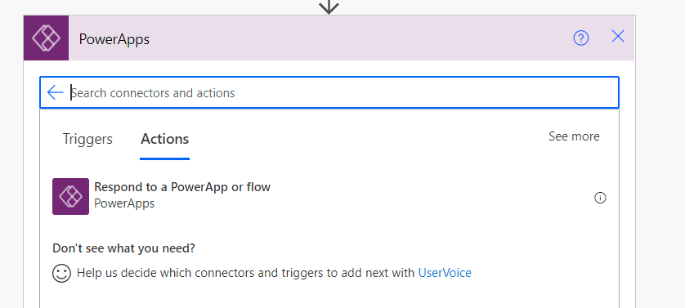

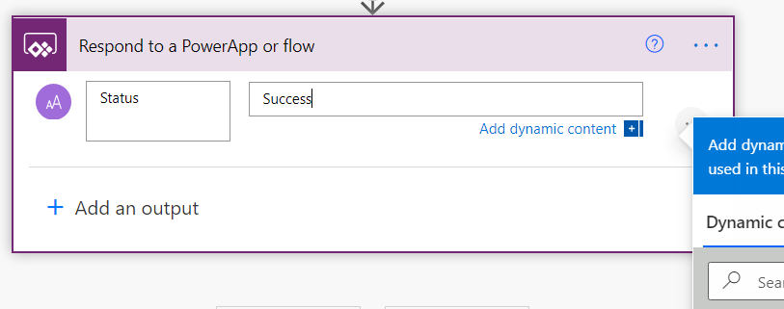

**Save it**

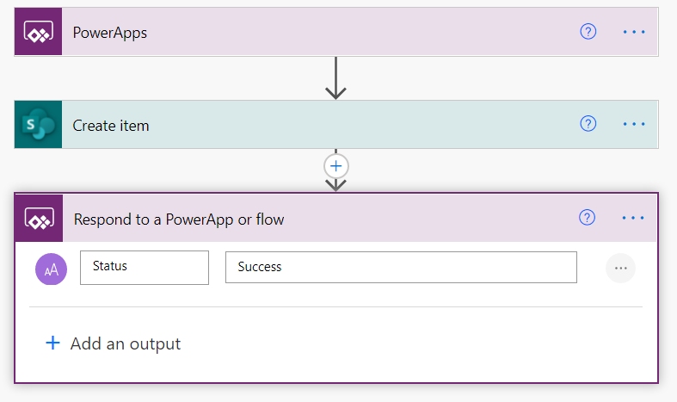

**Go to power apps and update the flow data source**

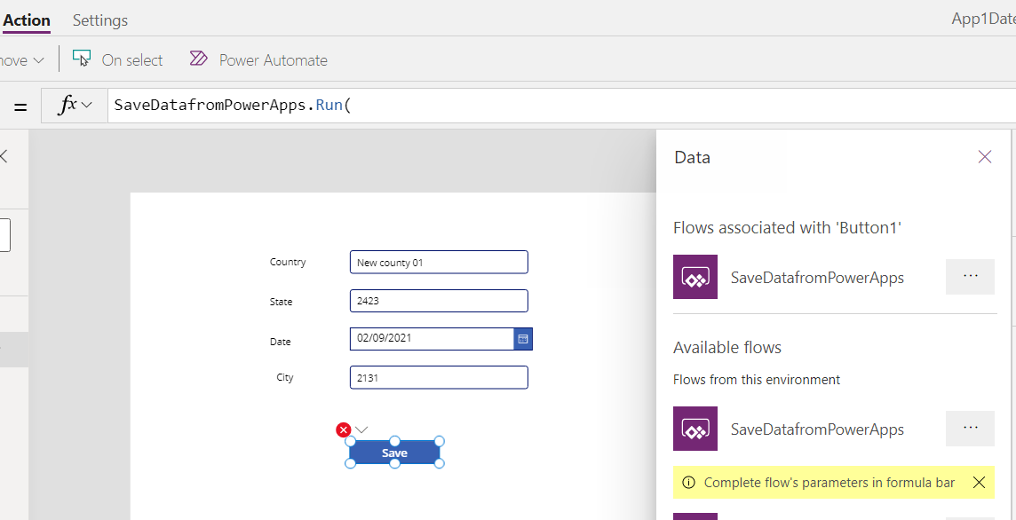

Then get the return status via variable.

Set(returnval,SaveDatafromPowerApps.Run(txt_country.Text,txt_state.Text,Text(DatePicker1.SelectedDate, "yyyy-mm-dd"),txt_city.Text))

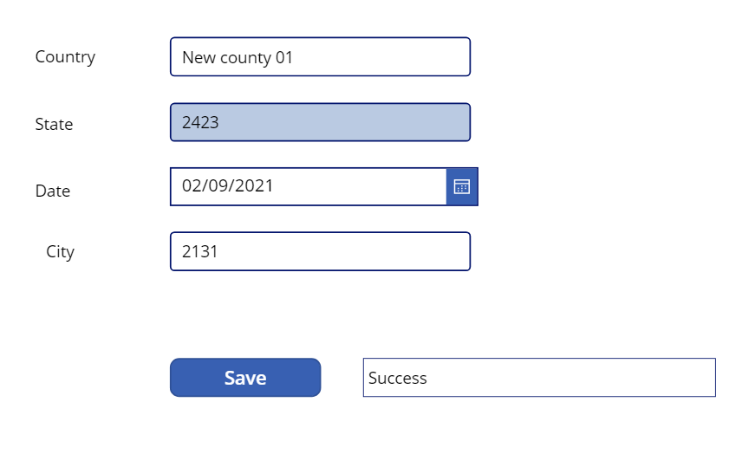

Add one label box and assign the value to Text

